محمد مصطفي السيد مصطفي

ID STUDENT : 801

BN :23

Date/ 11/6/2021

TOPIC computer engineering in covid 19

the COVID-19 pandemic has mobilized the world’s scientific community like no other recent crisis, including many researchers using the most modern data science and artificial intelligence approaches. At the University of Chicago, public health experts, computer scientists, economists and policy analysts have launched projects using computational tools to better detect, diagnose, treat and prevent the spread of the deadly virus.

Application BRIEF ::::
The early toll of the COVID-19 pandemic revealed severe health inequities in who catches the disease and who suffers death and morbidity. Latin and African Americans are more than three times as likely to catch the virus and twice as likely to die as white Americans, according to CDC data. Many experts believe this disparity goes beyond medical comorbidities, to social determinants such as housing, jobs and neighborhood features As the coronavirus pandemic is unprecedented, the present work aimed to review scientific contributions and official resources published no more than two years ago.

ICT and AI are already helping in agriculture and food engineering: picking vegetables, controlling pest infestations, soil and crop health monitoring and predictive analysis are only a few examples. Improving food traceability as well as the efficiency that can be gained through robotics, automation and digitization in supply chain logistics are some of key requirements for the near future of food safety. Indeed, notwithstanding the essential role of farm, factory and food workers, it is recognized that any human interaction with the food value chain, at least in the context of a virus, presents some risk.

((Screen shoots))
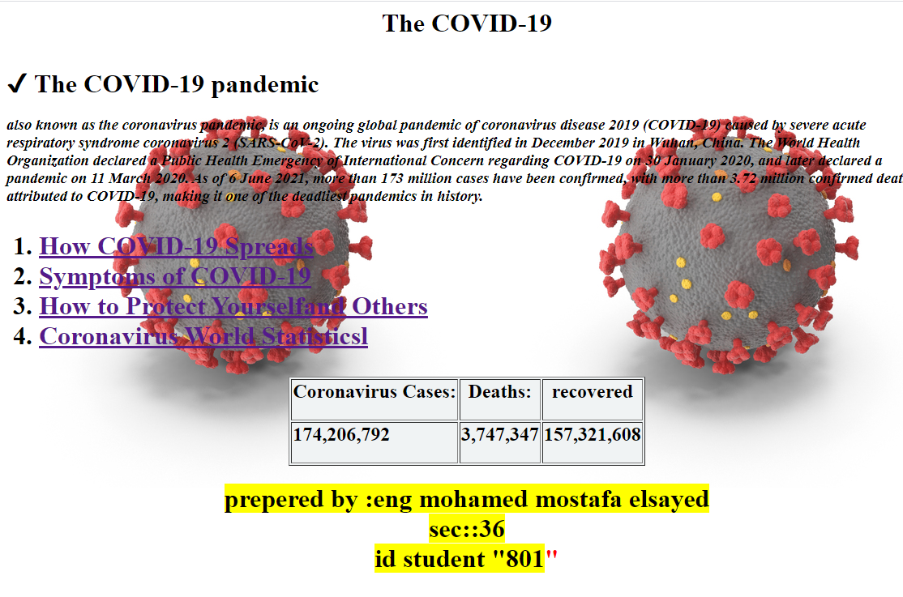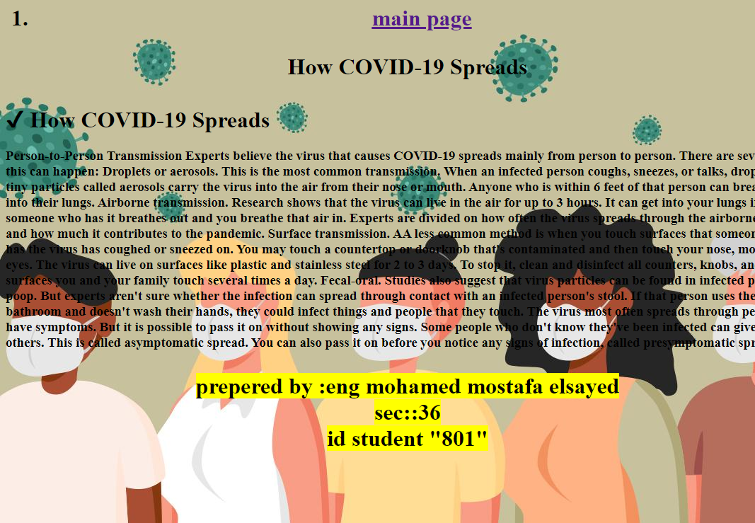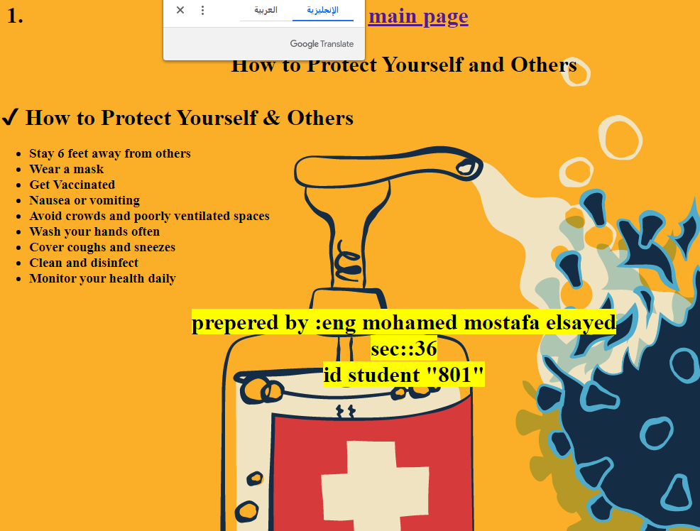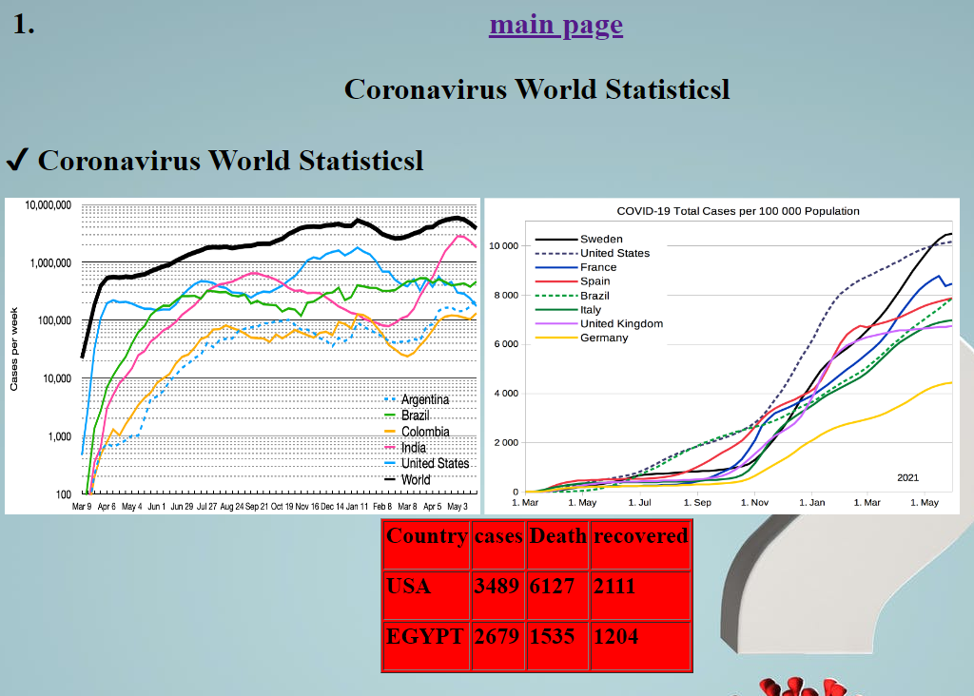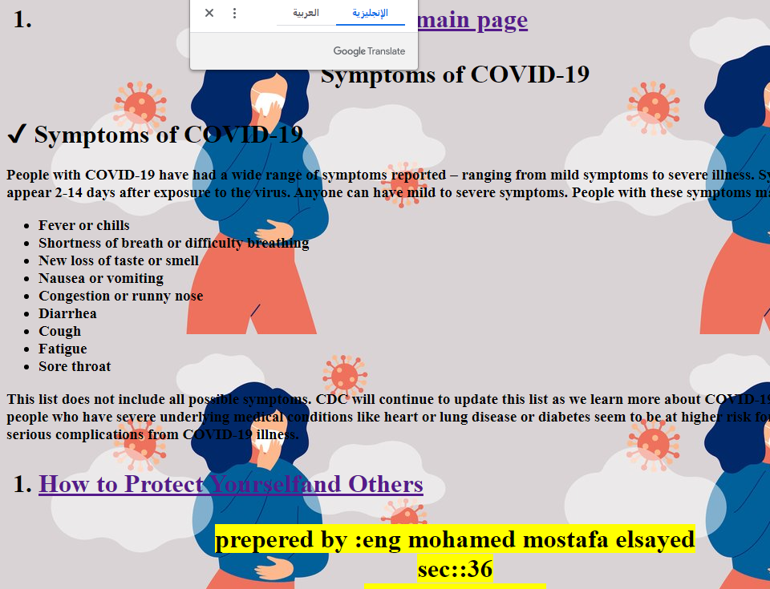

{ Soruce code }

<html>
<head>
<style>
body{
background-image: url('j.jpg');
}
</style>

<title>The COVID-19 </title>
</head>

<body >
<center> <h1> <p>The COVID-19 </p> </h1></center>
<h1> &#10004; The COVID-19 pandemic</h1>
<p><i><h3>also known as the coronavirus pandemic,
is an ongoing global pandemic of coronavirus disease 2019 (COVID-19) caused by
severe acute respiratory syndrome coronavirus 2 (SARS-CoV-2).
The virus was first identified in December 2019 in Wuhan, China.
The World Health Organization declared a Public Health Emergency of International Concern regarding COVID-19 on 30 January 2020,
and later declared a pandemic on 11 March 2020.
As of 6 June 2021,
more than 173 million cases have been confirmed, with more than 3.72 million confirmed deaths attributed to COVID-19,
making it one of the deadliest pandemics in history.</h3></i></p>
<h1>
<ol>
<li><a href="How COVID-19 Spreads.html">How COVID-19 Spreads </a>
</li>
<li><a href="Symptoms of COVID-19.html">Symptoms of COVID-19</a>
</li>
<li><a href="How to Protect Yourselfand Others.html">How to Protect Yourselfand Others</a>
</li>
<li><a href="Coronavirus World Statisticsl.html">Coronavirus World Statisticsl</a>
</li>
</li>
</ol>
</h1>
<center>
<table border="1"bgcolor="#F0F3F4"><tr> <th><h2>Coronavirus Cases:</h2>
</th> <th> <h2>Deaths:</h2</th>
<th> <h2>recovered</h2></th> </tr>
<tr>
<td><h2>174,206,792</h2></td>
<td><h2>3,747,347</h2></td>
<td><h2>157,321,608</h2></td> </tr>

</tr>
</table>
<font color="red"><h1><mark>prepered by :eng mohamed mostafa elsayed
<br>sec::36 <br>id student "801</mark>" </h1>
</font>

</center>
</body>
</html>

